**Screenshot’s of the multiplication quiz project**

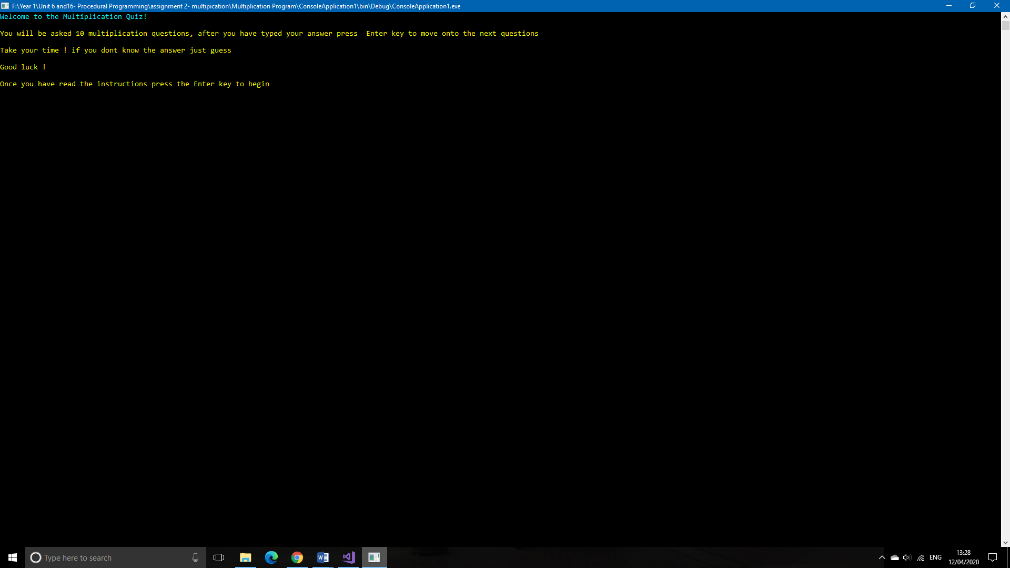

This is welcoming and guiding the user about how to answer the multiplication questions.

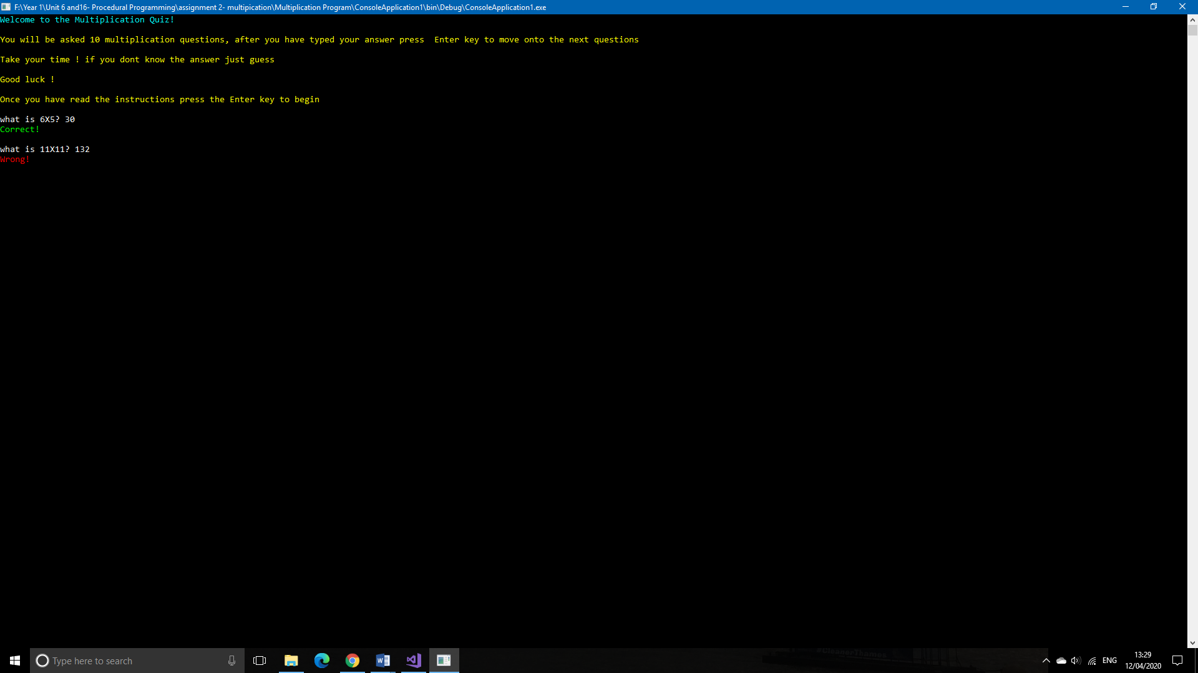

The user has submitted the answer and it has marked the question and it’s told the user that the answer is correct in green.



The user has inputted the answer and it has been marked and it has displayed a message saying it’s wrong in red.

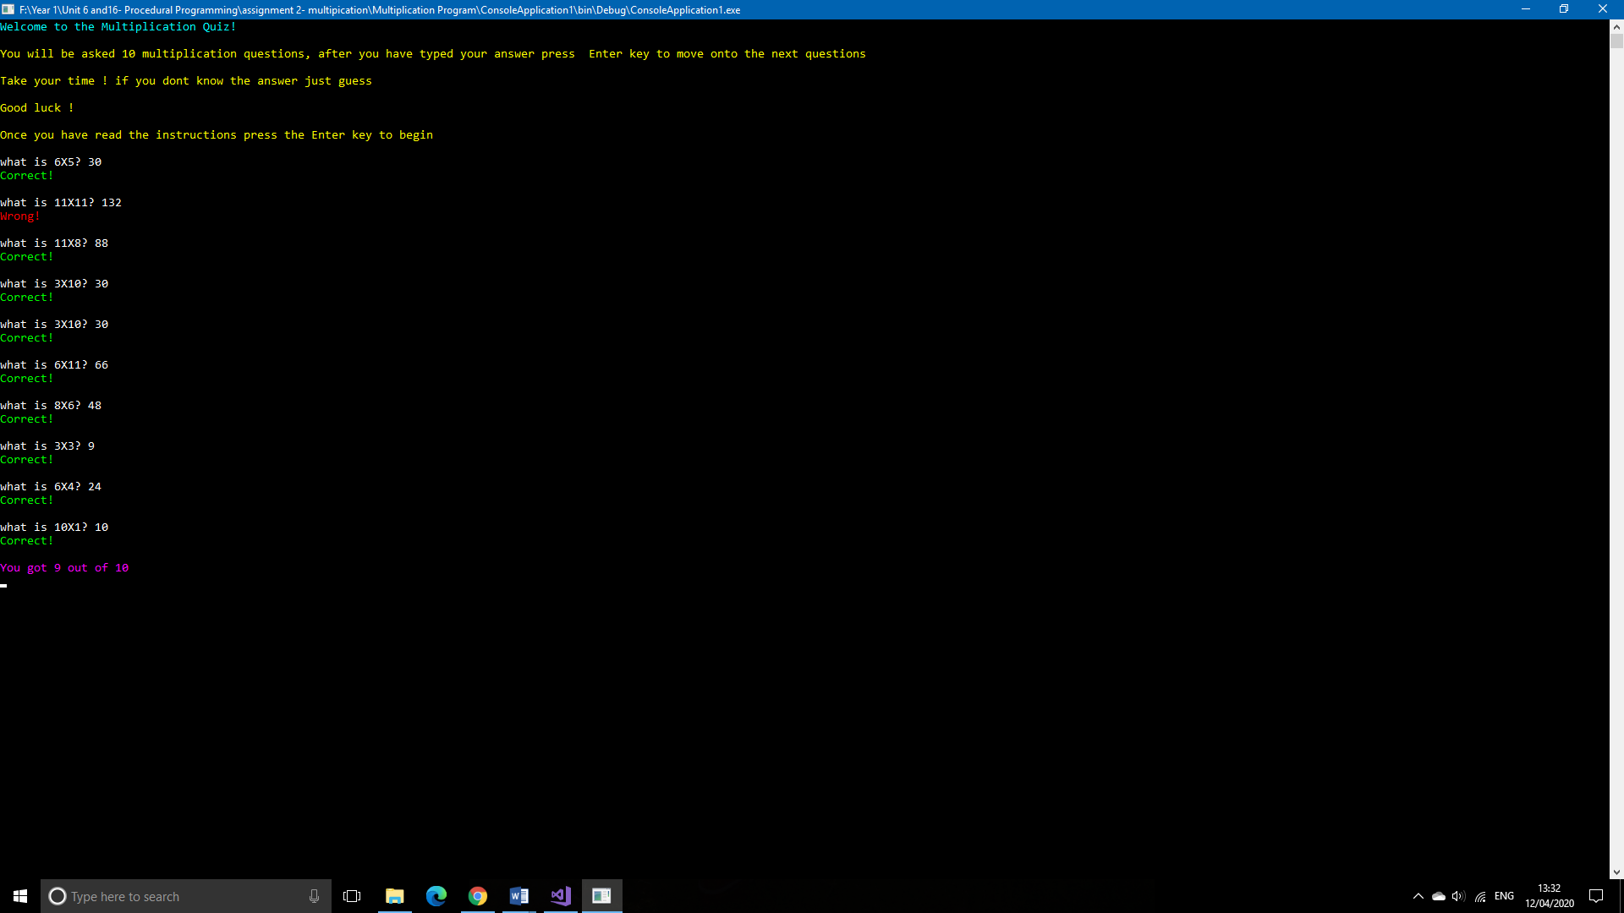

At the end of the quiz the user will have a score out of 10 which will indicate the questions they had correct.